Lab 13: The Sleuth Kit
What You Need for this lab
  - Install Virtualbox : https://www.virtualbox.org/wiki/Downloads
  - Install Kali 2021.4. : https://old.kali.org/kali-images/kali-2021.4/
Notes: Suggest You configure the disk size of Kali VM 80G because the size of each leakage cases image is 30G+
  - The Sleuth Kit
  - Assume we have the image file
  - https://www.dropbox.com/s/nw23q14vzsykyup/Ch01InChap01.dd
Step 1.
- Download a USB image
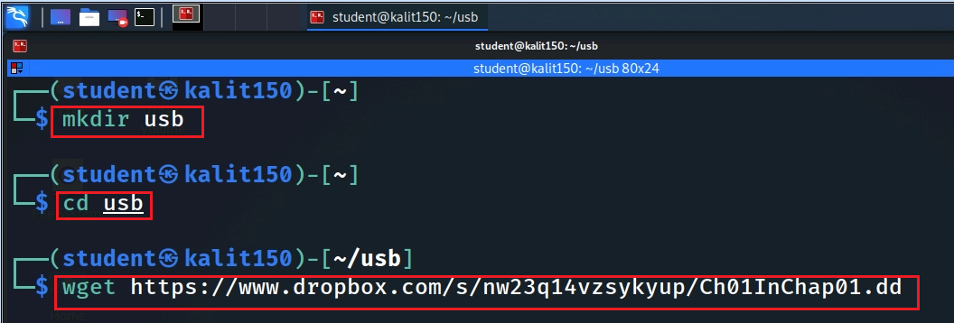
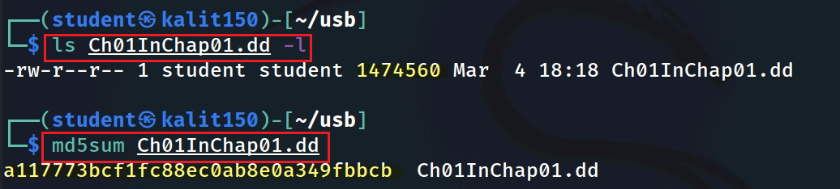
- Tool will show the details of the image format
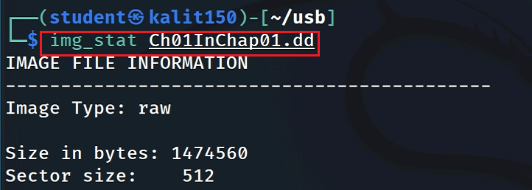
- Show file system details and statistics including layout, sizes, and labels.
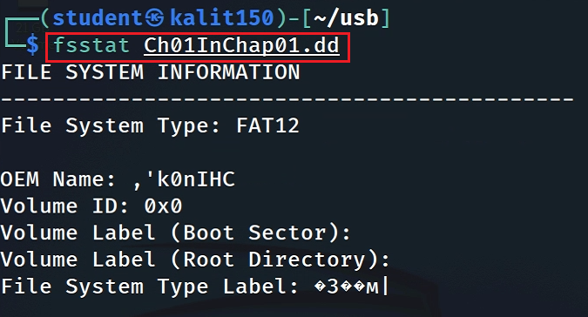
- List allocated and deleted file names in a directory
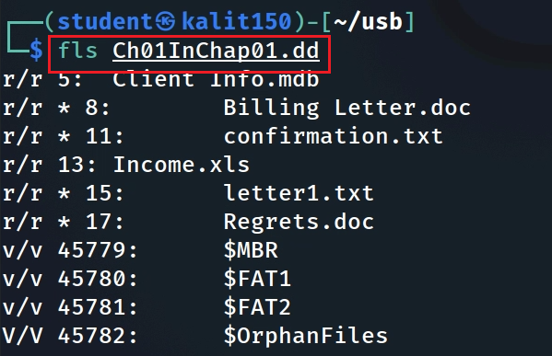
-d Display deleted entries only
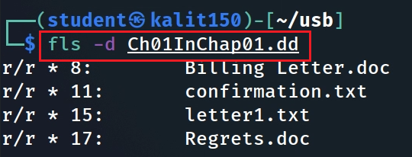
- Recover deleted file using inode
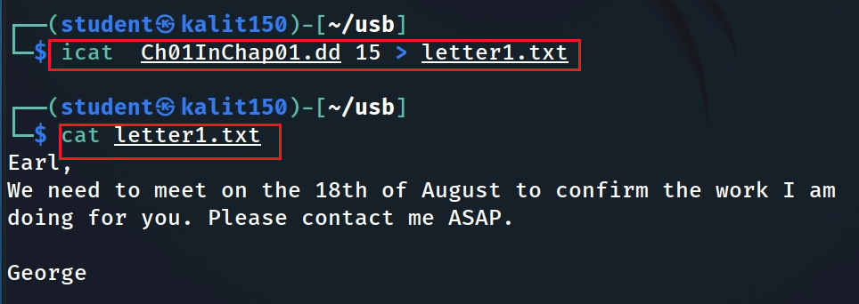
- Extract the data units of letter1.txt (inode15)
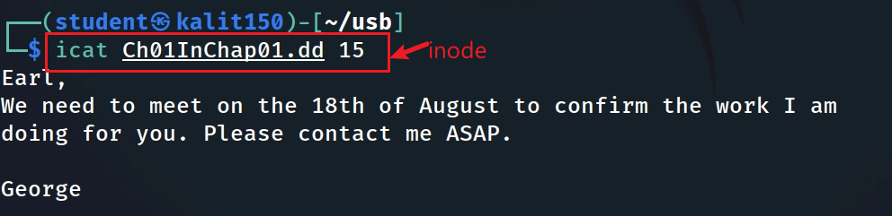
- Display the statistics and details about a given meta data structure
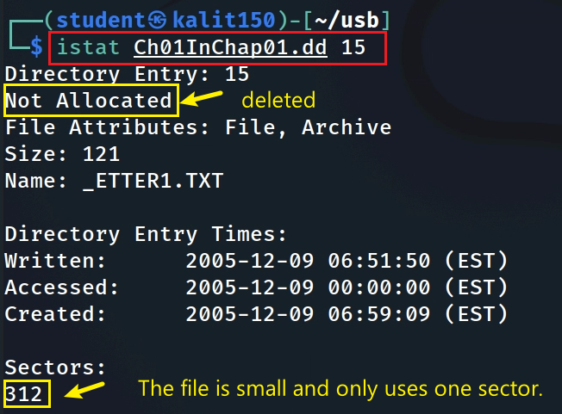
- List the details about data units and can extract the unallocated space of the file system
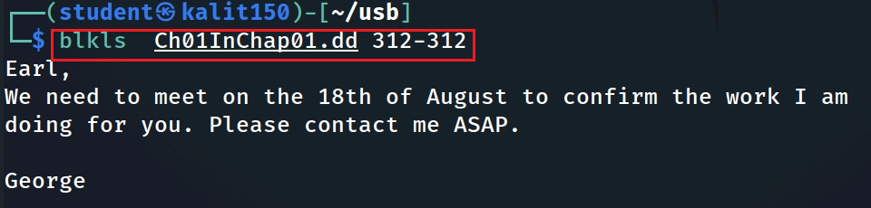
- Extract the contents of a given data unit in Hex
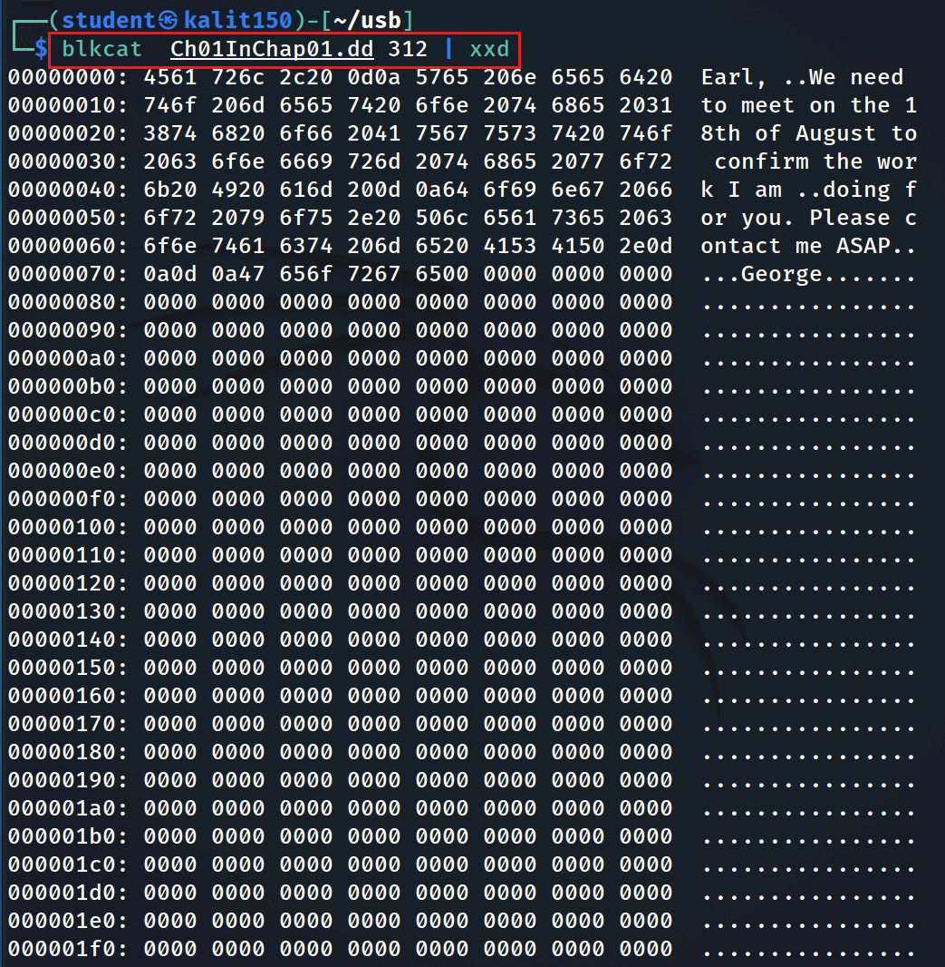
- Show A file with multiple sectors
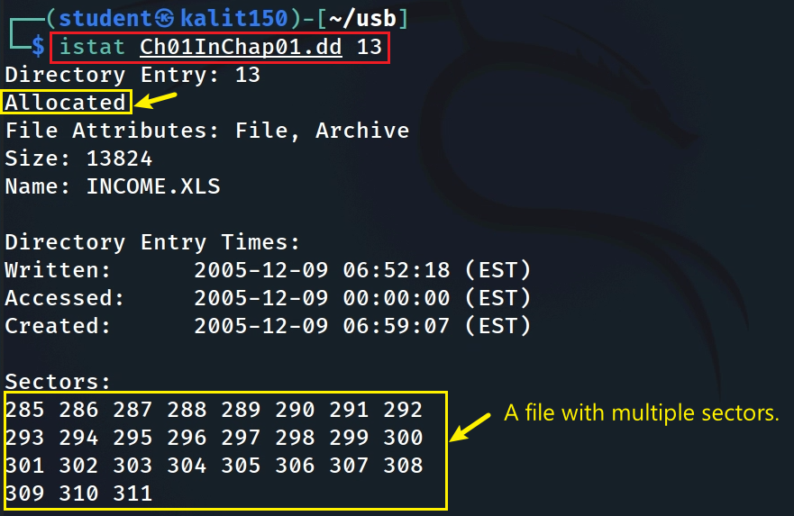

    - Assignment
Mounting a USB image
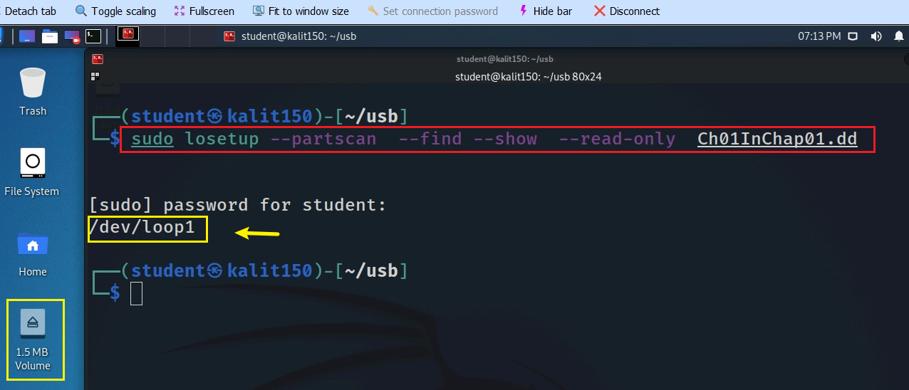
- Mount the USB image
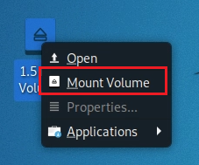
- Show content
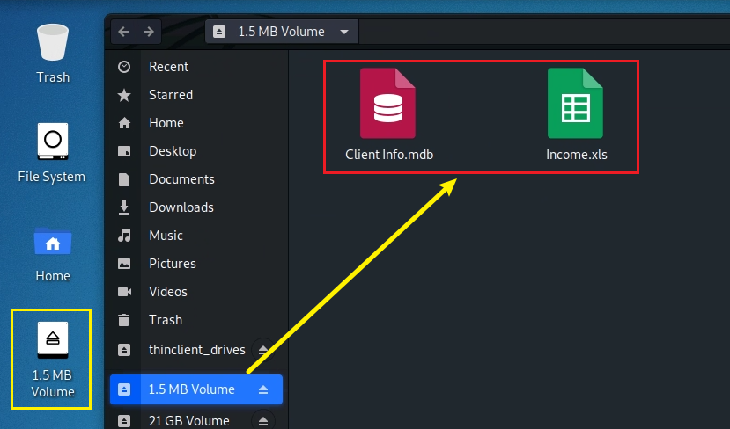
- Show the disk content
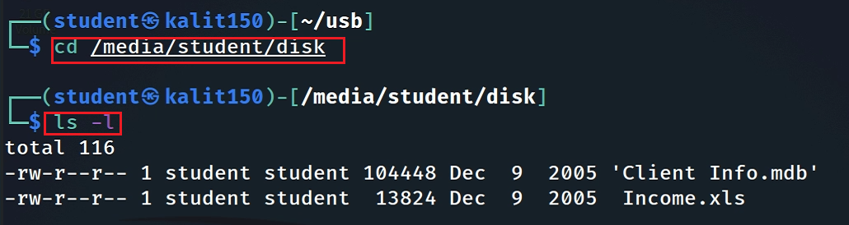
Exercise
- Follow the DOCX and practice all Linux commands
- How many deleted files in the disk image?
- Recover all deleted files
  - Without mounting
  - Only using the commands introduced in this lecture

YOU MUST SUBMIT A FULL-SCREEN IMAGE FOR FULL CREDIT!
Save the document with the filename "YOUR NAME Lab 13.pdf", replacing "YOUR NAME" with your real name.
Email the image to the instructor as an attachment to an e-mail message. Send it to: xxx@fe.edu.vn with a subject line of "Lab 13 From YOUR NAME", replacing "YOUR NAME" with your real name.

